1. 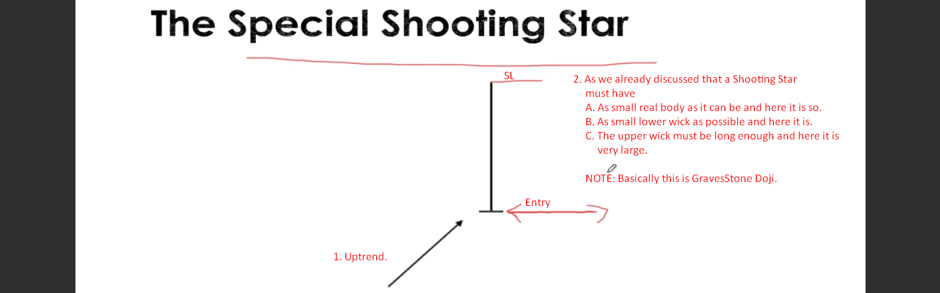
2. **NOTE**: Above we talked about special Shooting Star 🡺 Gravestone Doji but in the below start it is not the case. It is Normal Shooting Star. 😊  
   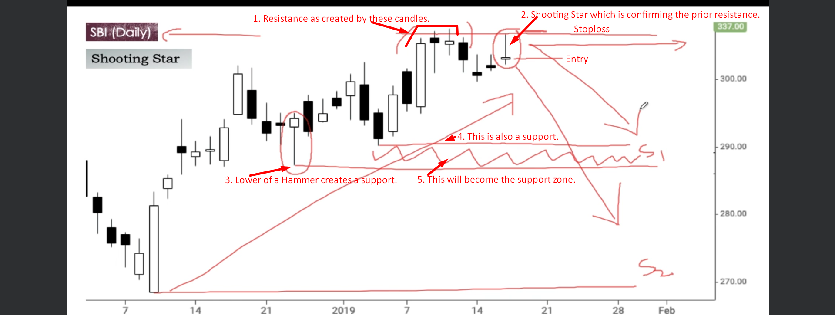
3. 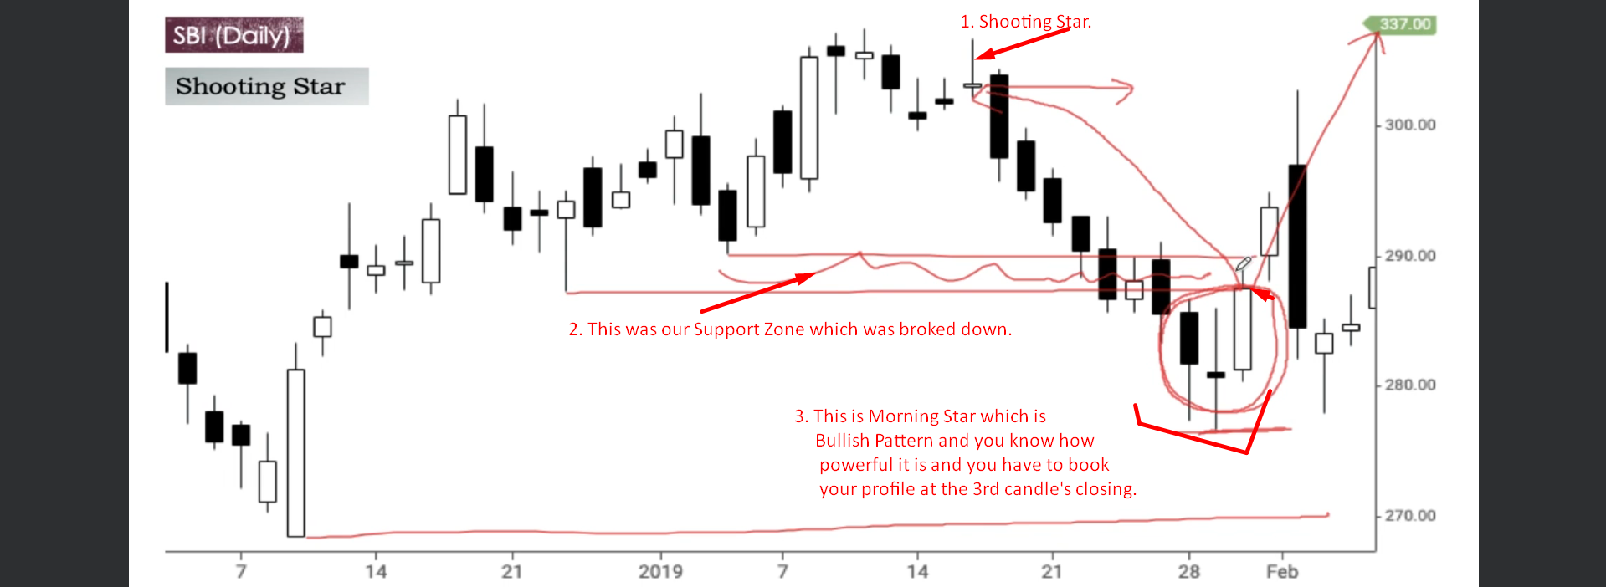
4. 
5. 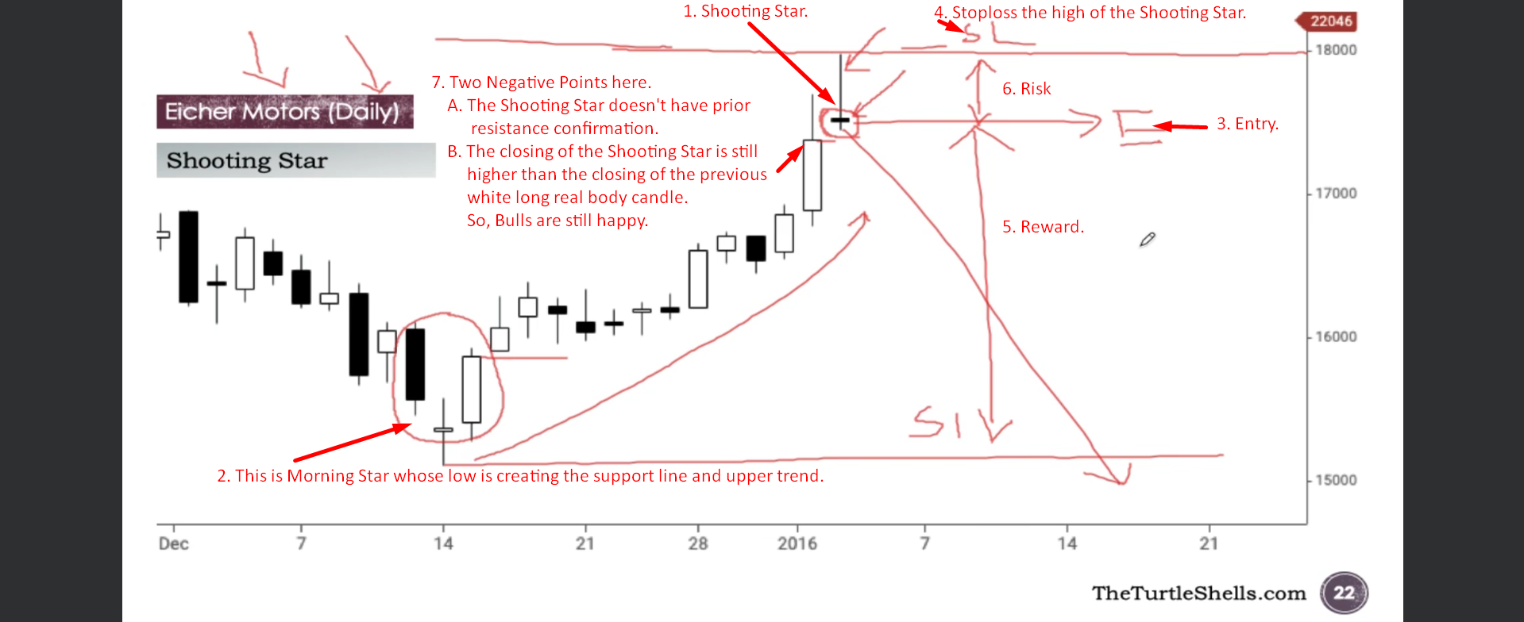
6. 